**FORECASTING IN EXCEL**

**METHOD 1:**

* **Using Formulae**

**=Forecast(x,Known_ys,Known_xs)**

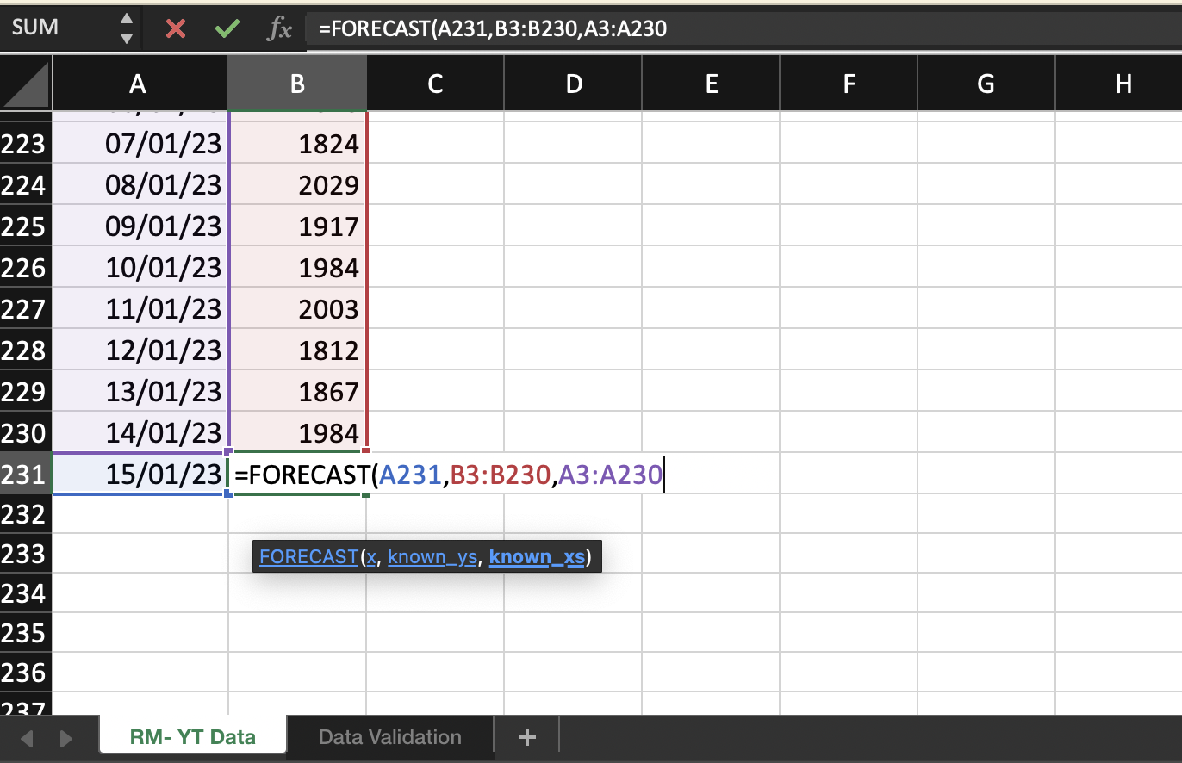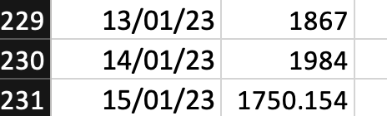 **OUTPUT: 1750.154** 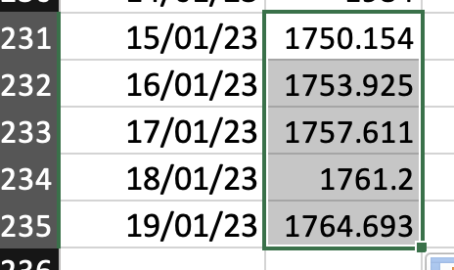

**OUTPUT FOR EXTENDED DATES**

**METHOD 2: GRAPH TRENDLINE**

* **Linear Trendline**

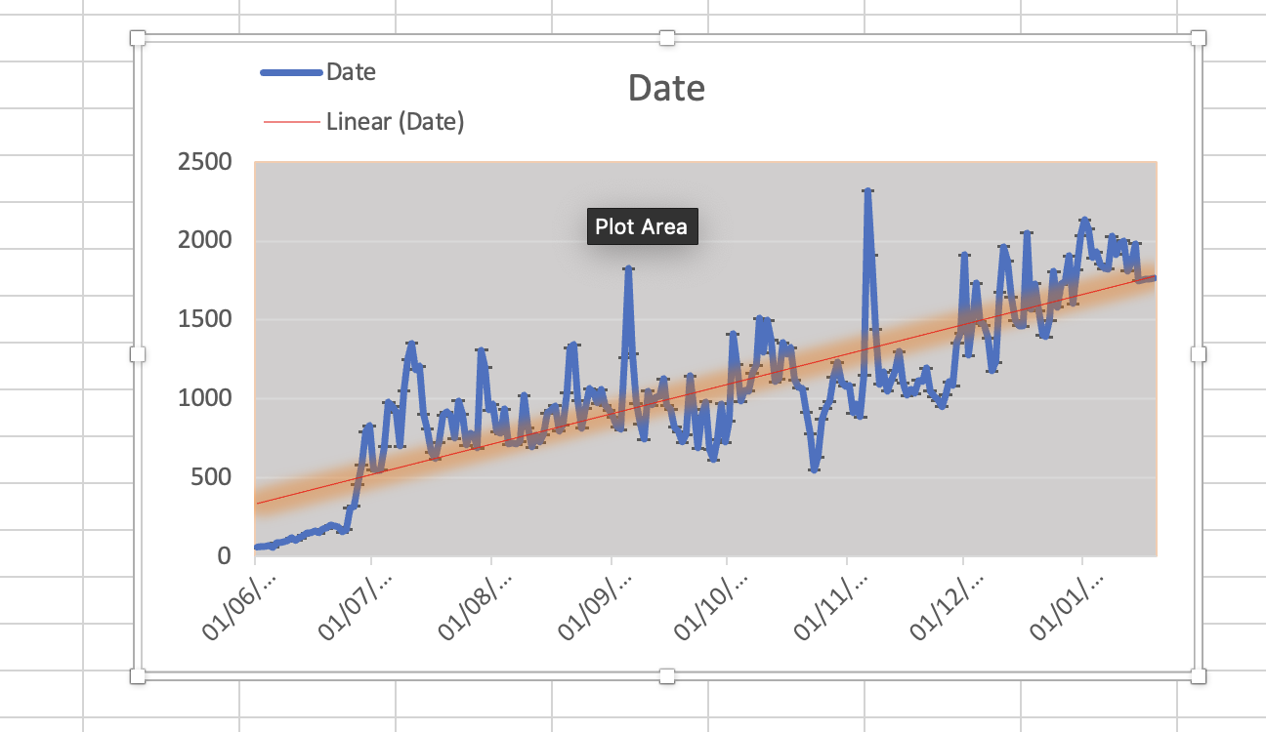

* **Exponential**

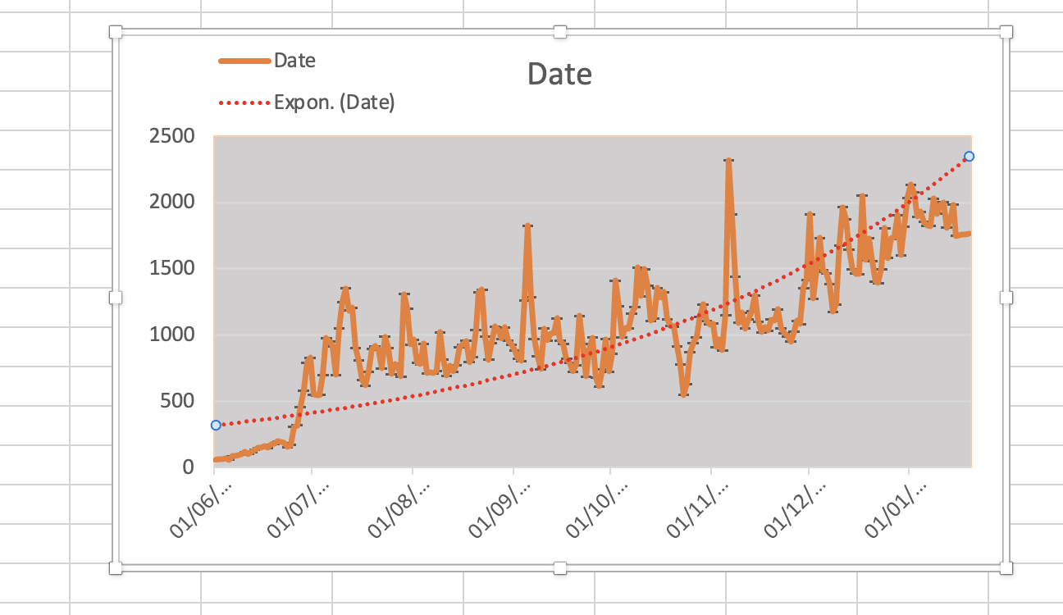

**METHOD 3: FORECAST SHEET**

